**S. S. DHAMDHERE COLLEGE, TALEGAON DHAMDHERE**



**A**

**PROJECT REPORT ON**

**LIBRARY MANAGEMENT SYSTEM**

**FOR THE PRACTICLE FUILFILLMENT OF**

**BCA EXAMINATION 2015-2016**

**SUBMITED TO**

**SAVITRIBAI PHULE PUNE UNIVERSITY**

**SUBMITTED BY**

**DNYANESHWAR NAIKNAVARE**

**KISHOR JEDHE**

**UNDER THE GUIDANCE OF**

***MRS. p. m. Pawar***

***mrs. a. s. bhumkar***

**S.S.dHAMDHERE COLLEGE OF aRTS & COMMERCE**

**( BCA department )**

***Certificate***

*This is to certify that Project entitled ‘Library Management System’ was completed by Mr. Naiknavare Dnyaneshwar Panditrao(Seat No : 47829) & Mr. Jedhe Kishor Chandravadan(Seat No :47828) . As a requirement of T.Y.B.C.A (Semester V) Examination for the academic year 2015-2016 for University of Pune.*

***Internal Examiner External Examiner***

***Head of Department Principle***

***ACKNOWLEDGEMENT***

*We are the student of T.Y.B.C.A division, very glad to present this Visual Basic project on “Library Management System” to Savitribai Phule Pune university our project would have been incomplete without help of our computer teachers.*

*We are very grateful to miss. Prajakta Pawar for their excellent guidance and encouragement. We are also very much thank full for their valuable suggestion and the supportive role played by them in the entire undertaking.*

*It gives me great pleasure to acknowledge the assistance of the college Staff and our friends who through their kindness and thoughtfulness have helped me throughout. We are deeply owned to our family members for morally boosting us.*

*Yours Sincerely*

*Mr. Dnyaneshwar Naiknavare.*

*Mr. Kishor Jedhe.*

***INDEX***

1. *Introduction*

* *Introduction to system*
* *Scope of the system*
* *Proposed System*
* *Features of Proposed System*
* *Objectives*

1. *Analysis*

* *Fact Finding Techniques*
* *Feasibility Study*
* *Hardware & Software Requirements*

1. *System design*

* *ERD*
* *CONTEXT LEVEL Diagram*
* *DFD*
* *Data Dictionary*

1. *Form Design(with input values)*
2. *Report*
3. *Advantages and Limitations*
4. *Future Enhancement*
5. *Bibliography*

**INTRODUCTION**

**INTRODUCTION TO THE SYSTEM**

*Library Management System is a software build which is used to automate functions of library using computer.*

*Library Management System provides one attractive environment where you can manipulate data & information about Books, Readers, and administrator easily.*

*The security of Library data, Books Information is given first priority by the System. System stores all information into the databases in MS Access which is easy to manipulate.*

***EXISTING SYSTEM***

*The existing system contains manual records. Records were stored on paper. Difficult to search student and book record.*

*Updation and deletion of record is difficult regarding books students etc.*

***PROPOSED SYSTEM***

*To overcome the drawbacks of the current system, a new system is proposed in the form of software. All the data is inputted to the system through input forms. The data is then stored in tables in appropriate format. Whenever it is required to retrieve the data, it can be retrieved very easily as computer databases are very easy to handle.*

*The software is developed using Microsoft Access as Back End Software. All the Data is stored in Microsoft Access tables using Microsoft’s Visual Basic. For retrieval of data, various queries are used. The database table formats are given in appendix.*

*For GUI (Graphics User Interface). Microsoft Visual Basic is used as front end Software. Various forms are designed for taking inputs and for printing various reports.*

**SCOPE OF THE SYSTEM**

* *Must be able to retrieve books and member Information*
* *Must be able to Create, add and navigate the records.*
* *Must be able to edit existing information.*
* *User must be able to search the record in database.*
* *To save the lot of time.*
* *User Friendly.*
* *Speedy Operations.*
* *Accuracy.*
* *Efficiency*

***OBJECTIVE***

1. *Increased speed of work.*
2. *Decreased cost and increased Performance ofLibrary.*
3. *Quick searching of any Books.*
4. *Give current status of Books.*
5. *Keep Security of Data.*

*.*

***FEATURES***

* *Reduced Paper Work.*
* *Human Errors are reduced*
* *Working is fast i.e time saved*
* *Easy Books Transactions*
* *Record details are also maintained*

**ANALYSIS**

***FACT FINDING TECHNIQUES***

*Various fact finding techniques were used to collect detailed information about each and every aspect of the Library Management System. In order to gather and analysis the relevant information the following fact finding techniques were adopted.*

1. ***Record Review and Document searching:-***

*We have Visited to our Library and checked records.A study of records maintained manually gave a clear idea as to how the actual process is carried out.*

1. ***Interviews:-***

*Timely discussions with Mrs. S. S. Gajbe(Librarian at our college) was made to understand the exact requirements of the system. These discussions were also useful in bringing up new ideas as to make system more effective. Through such invaluable techniques, it is possible to find much of the quality.*

***FEASIBILITY STUDY***

***1.Technical Feasibility:****Library Management system uses the concept of paperless transactions. Also, storing and searching of the book records is very accurate, reliable and is following all the rules for the same. Adding new Members And books to Library System is very easy. The time required for the proposed system very negligible as compared with the manual system, we can say that the proposed system is technically feasible.*

***2.Economical Feasibility:****For maintaining Books Transaction Records manually requires different types of documents, registers, member cards etc. But with our new software system this cost is reduced. So we can say that the system is economically feasible.*

***3. Operational Feasibility:*** *Our Softeware System is very Simple And Powerful. Any person Can Handle It.*

*1. It helps to prepare clearly understandable and faster transactions of book records .*

*2. With appropriate error messages for every screen this makes the system easy for librarian and user and very easy to operate any person.*

***HARDWARE SOFTWARE REQUIRMENT***

*Operating System : MS-Windows XP or Higher.*

*Back End : Microsoft Access 2007 or Higher*

*Front End : Microsoft Visual Basic 6.0*

*Other Software : 1. Microsoft Word*

*2. Microsoft Power Point*

**SYSTEM DESIGN**

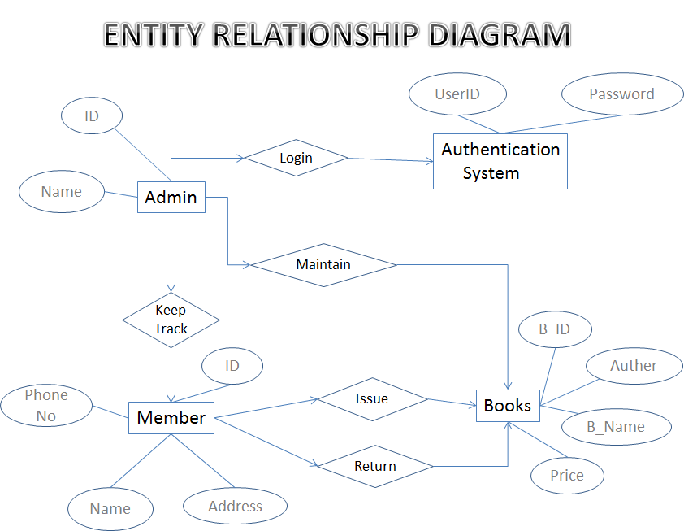

**CONTEXT LEVEL DIAGRAM**

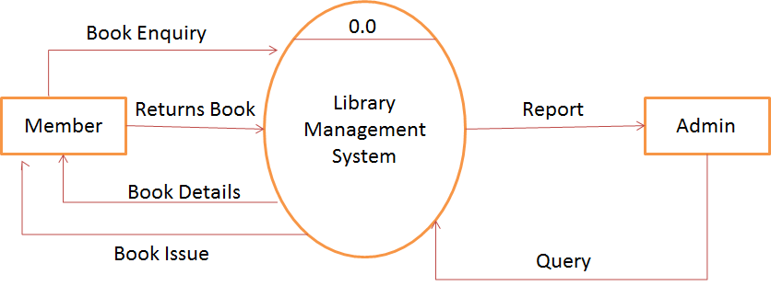

**FIRST LEVEL DFD**

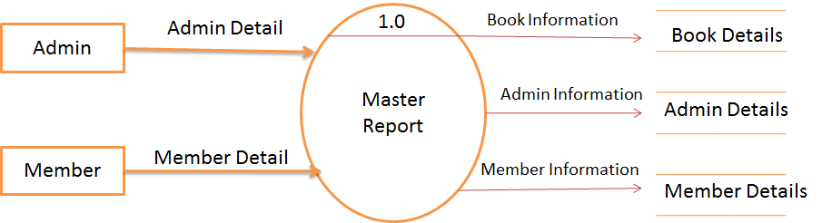

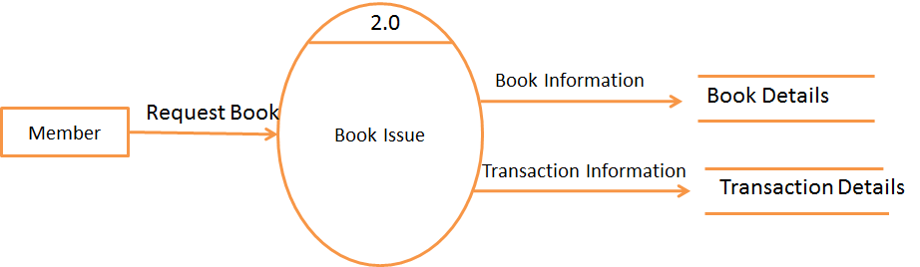

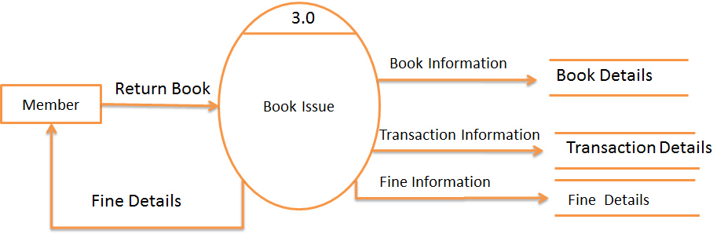

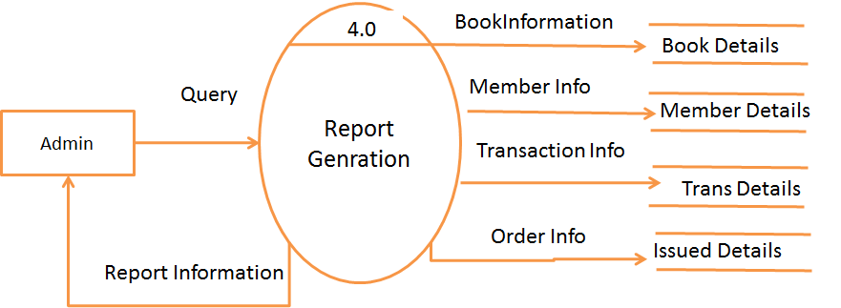

**DATA DICTIONARY**

1. Table Name : users

Purpose : This table stores user authentication information for logging in.

|  |  |  |
| --- | --- | --- |
| Field Name | Data Type | Description |
| Userid | Text | User ID |
| password | Text | password |
| Uname | Text | first name |

1. ***Table Name : books***

***Purpose : This table stores information about books.***

|  |  |  |
| --- | --- | --- |
| *Field Name* | *Data Type* | *Description* |
| *Bid* | *Number* | *Primary key* |
| *Bname* | *Text* | *Book name* |
| *Auther* | *Text* | *Auther of book* |
| *Publication* | *Text* | *Publication name* |
| *Date* | *Date* | *Date of book added* |
| *Category* | *Text* | *Category of book* |
| *bookstatus* | *Text* | *Status Of book* |
| *Price* | *Currency* | *Book price* |

1. *Table Name : Members*

*Purpose : This table Stores information of Members of Library.*

|  |  |  |
| --- | --- | --- |
| *Field Name* | *Data Type* | *Description* |
| *memberid* | *Number* | *primary key* |
| *membername* | *Text* | *name of member* |
| *memail* | *Text* | *email of member* |
| *mphone* | *Number* | *contact number* |
| *maddr* | *Date* | *address* |

1. *Table Name : Transaction*

*Purpose : This table transaction records of books*

|  |  |  |
| --- | --- | --- |
| *Field Name* | *Data Type* | *Description* |
| *bid* | *Number* | *Primary key* |
| *bname* | *Text* | *Book name* |
| *memberid* | *Text* | *Member id* |
| *mname* | *Text* | *Member name* |
| *issue_date* | *Number* | *Issued Date* |
| *return_date* | *Date* | *Return book Date* |
| *bookstatus* | *Text* | *Book availability status* |
| *fine* | *Integer* | *Fine charged* |

1. *Table Name : Issued_books*

*Purpose : This table stores information of issued books to members*

|  |  |  |
| --- | --- | --- |
| *Field Name* | *Data Type* | *Description* |
| *bid* | *Number* | *Primary Key* |
| *bname* | *Text* | *Book Name* |
| *Memberid* | *Number* | *Member id* |
| *Mname* | *Text* | *Member name* |
| *Issue_date* | *Date* | *Book issued date* |

**form DESIGN**

**(input value)**

LOGIN FORM

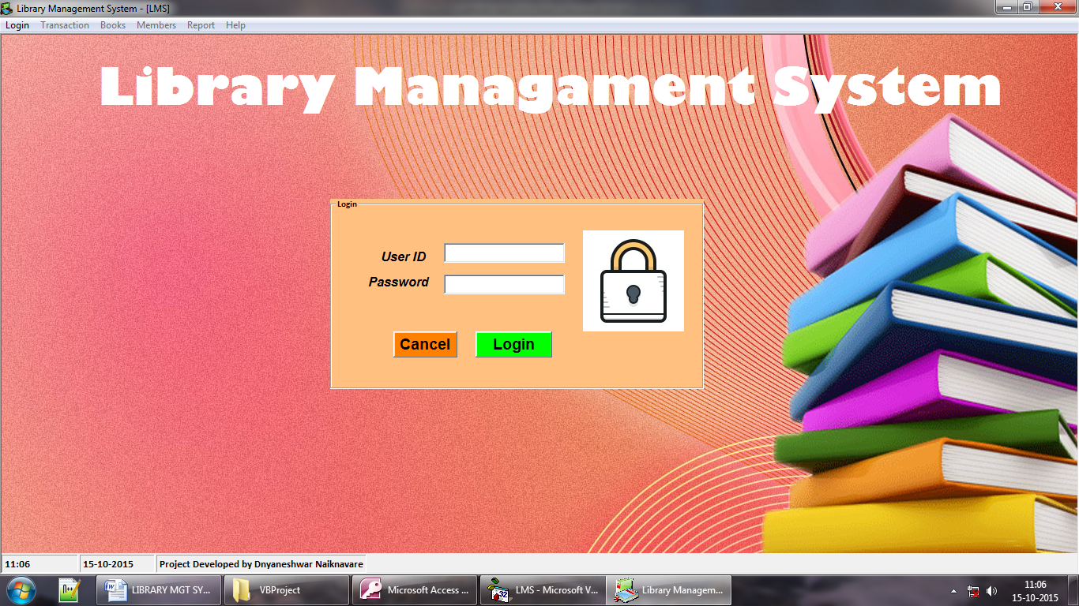

ISSUE BOOK

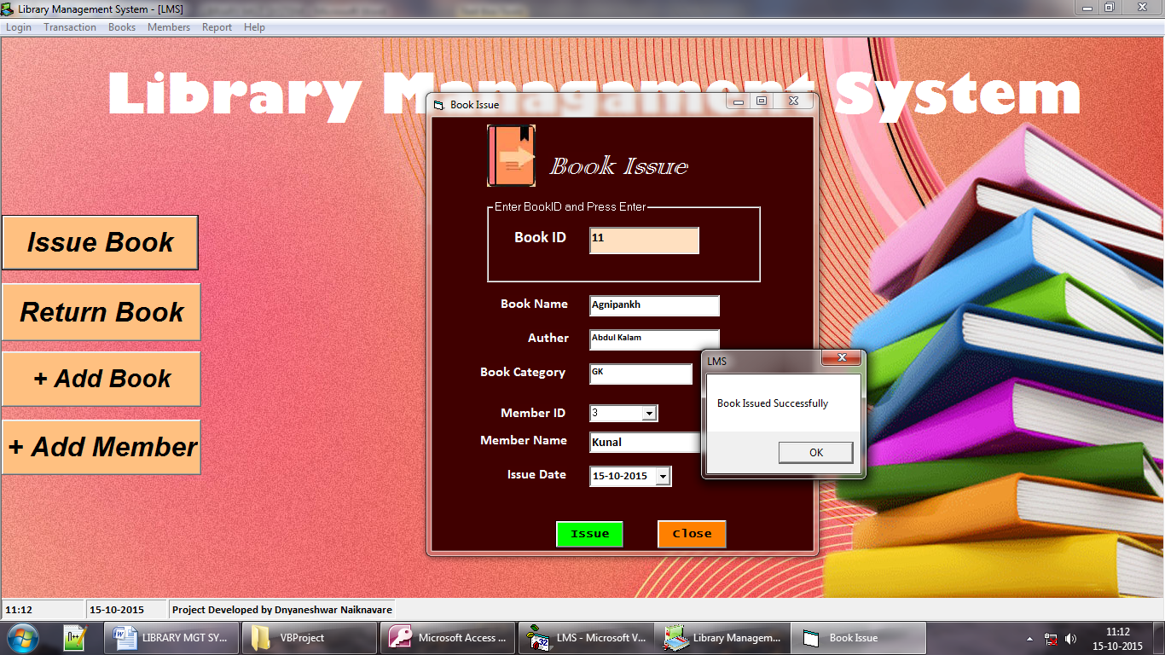

RETURN BOOK

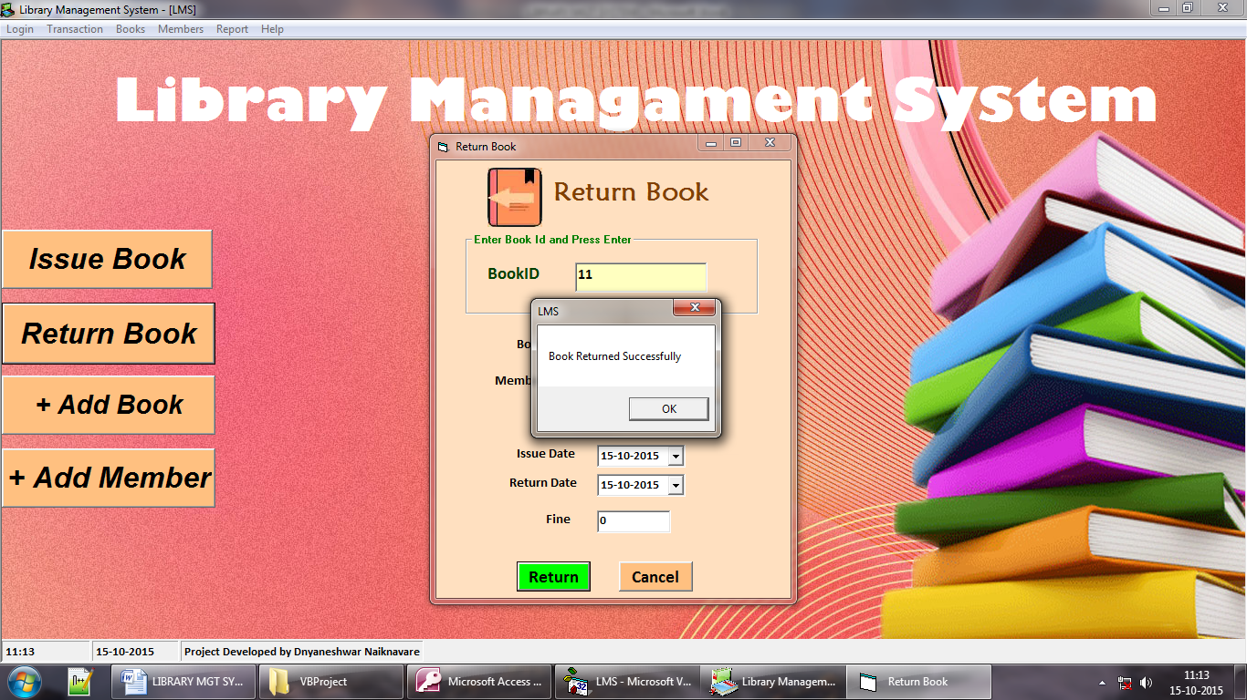

ADD BOOK

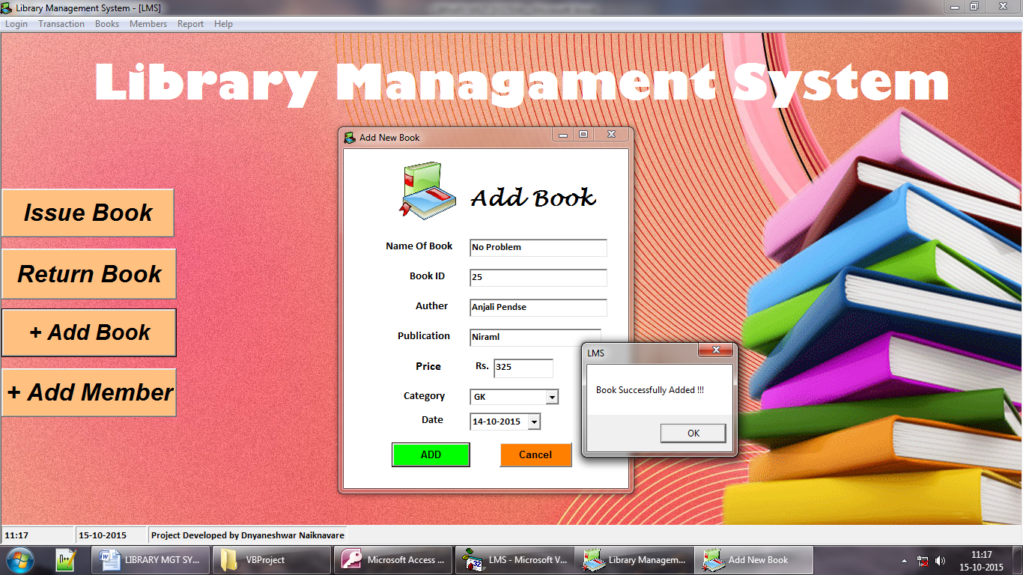

New User Registration

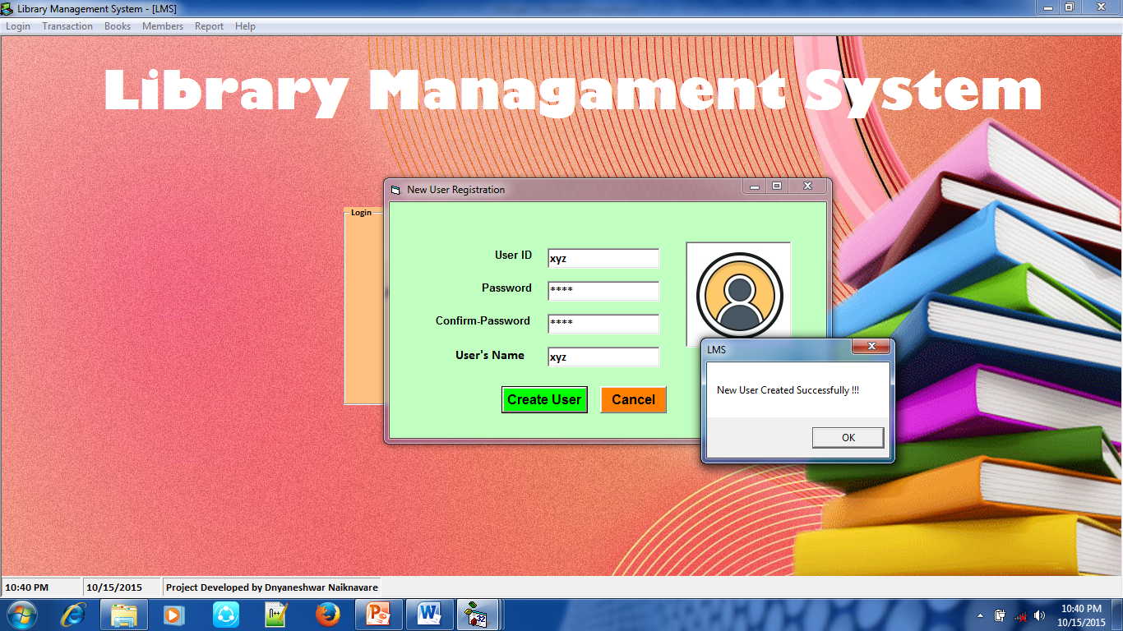

ADD MEMBER

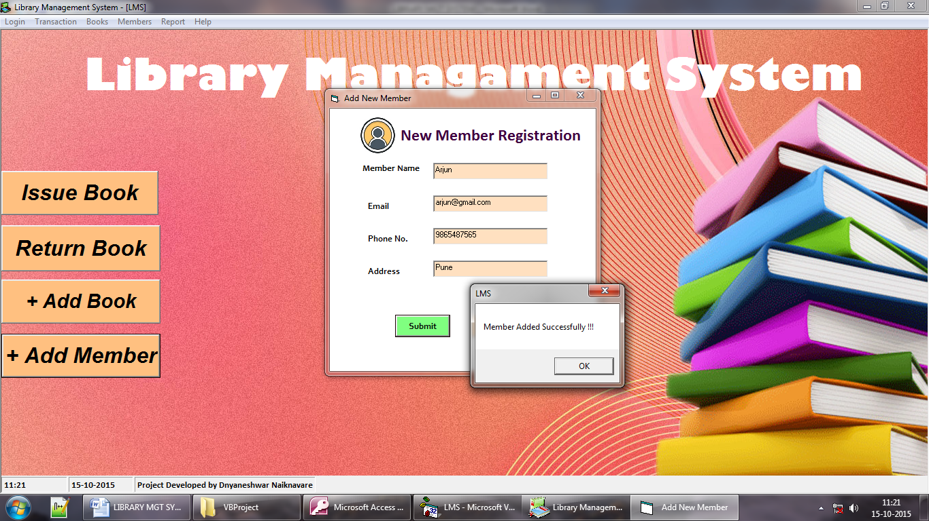

DELETE BOOK

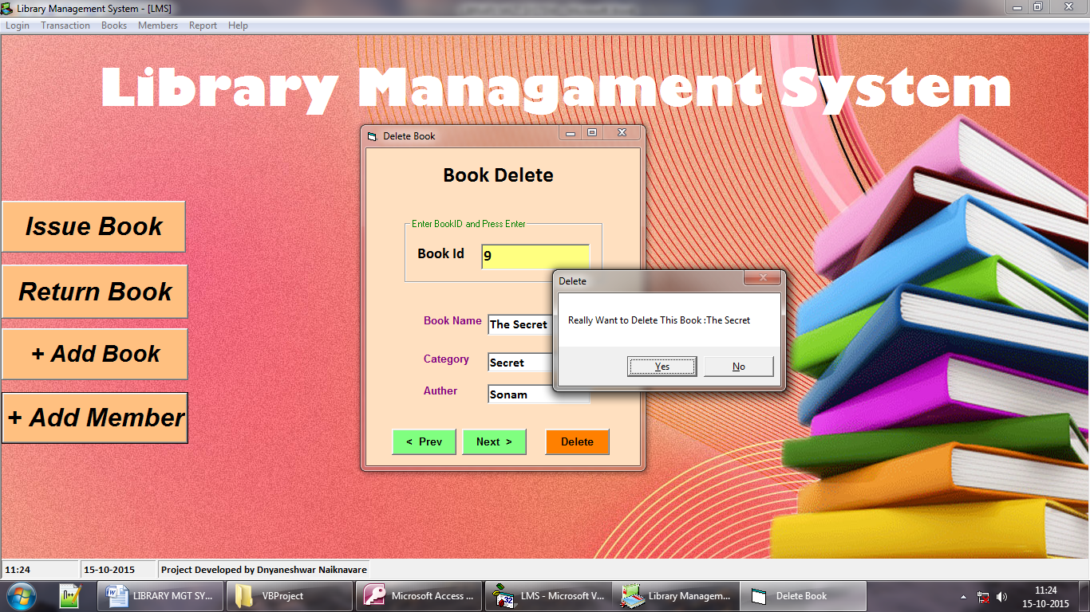

DELETE & UPDATE MEMBER

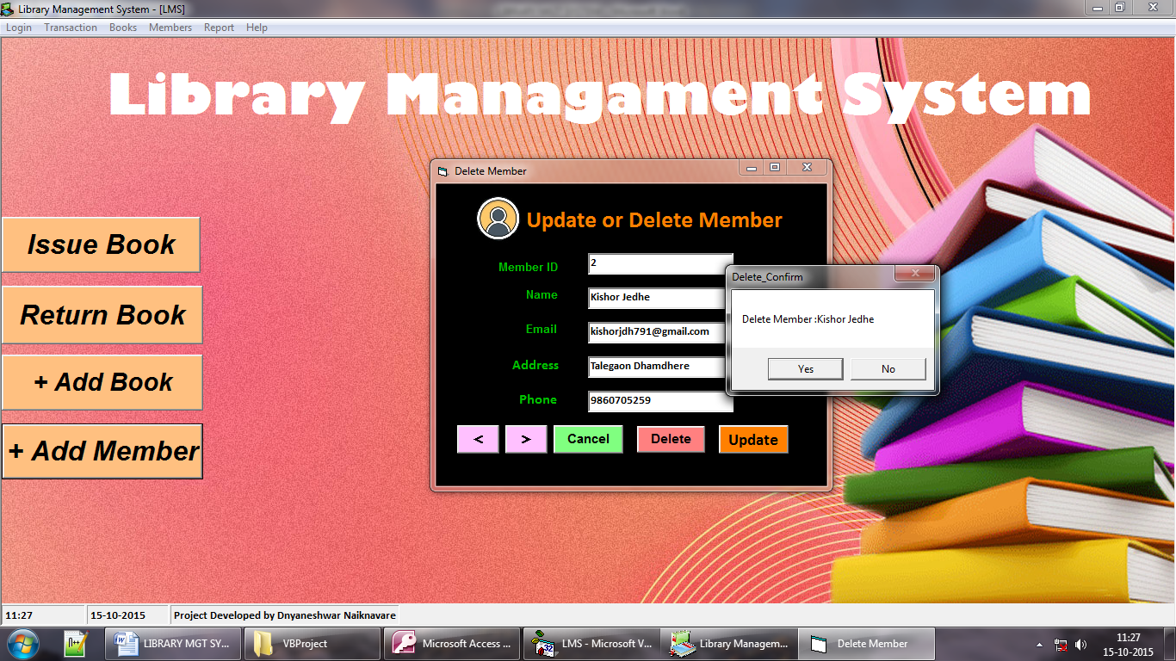

DELETE BOOK

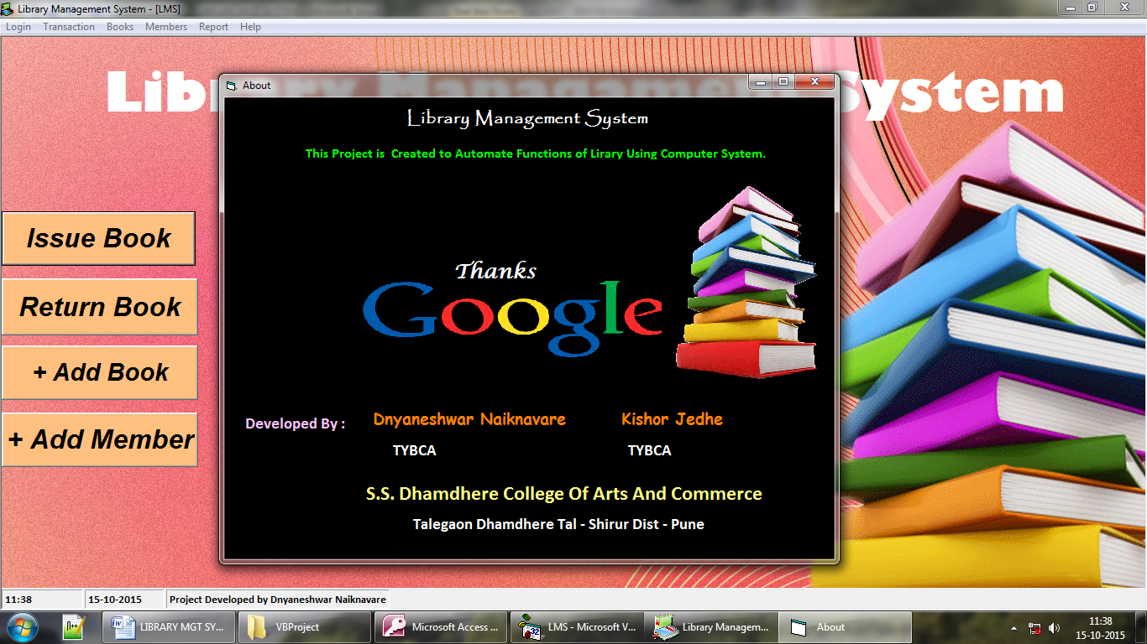

**REPORT**

BOOKS REPORT

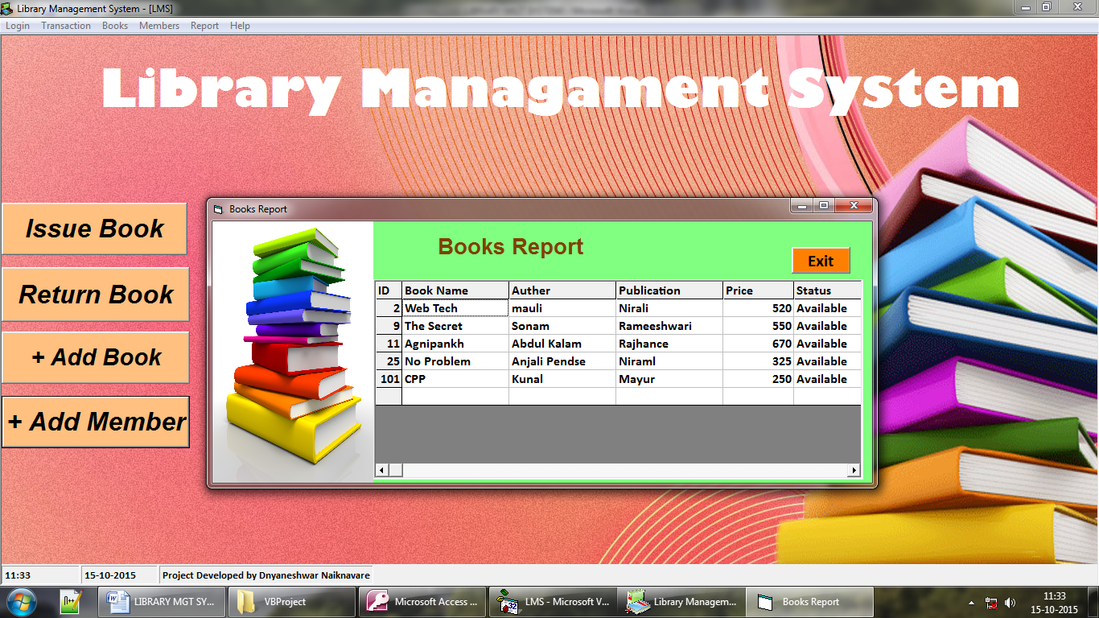

MEMBERS REPORT

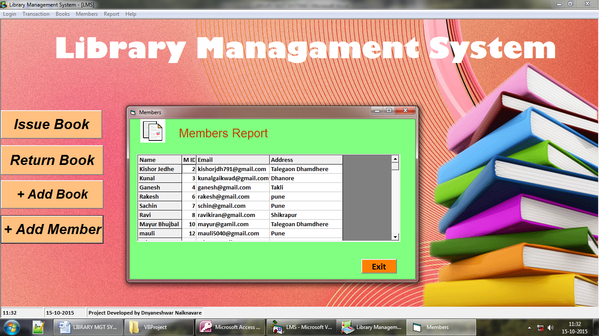

BOOKS REPORT

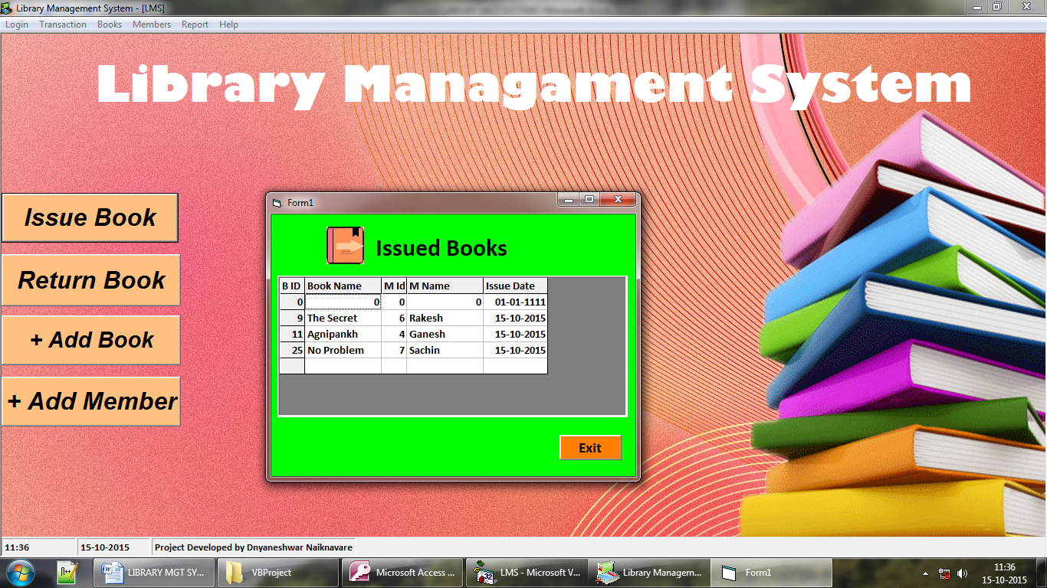

***ADVANTAGES***

1. ***User friendly****:*

*The system got much simplified screen which makes the system facts enhance quick and accurate data.*

1. ***Validation check:***

*The system has various validation check and it also gives*

*Appropriate error message and necessary help.*

1. ***Report generation:***

*The system can generate various reports giving customer details.*

***LIMITATIONS***

1. *This project is not online*

***ENHANCEMENTS***

*Although there are no more drawbacks of this system following are the possible enhancement of this system.*

*Enabling this system for multi-user environment and networking, so that multiple administrators can handle system from multiple places.*

*Instead of using access as back end, Oracle or SQL Server is proposed back end so that manipulation of large data becomes easy and efficient due to RDBMS.*

***CONCLUSION***

*Working on this project was a good experience. Working together in a team helped to communicate better. We understood the part of designing & planning as a part of software development.*

*With this we come to the end of our project documentation. Hope it would serve all the requirements needed to understand the system. Hope to get your feedback for further improvements.*

**BIBLIOGRAPHY**

Advanced Visual Basics 6.0

* Visual Basics Black Book.
* Same Teach Yourself Visual Basic 6.0 in 21 Days.

Websites

* [**www.google.co.in**](http://www.google.co.in)
* [**www.tutorialspoint.com**](http://www.tutorialspoint.com)
* [**www.shriwebworld.in**](www.shriwebworld.in)

***=============***

***Thank You !***

***============***